LAB ACTIVITY
15. Write a Pandas program to keep the rows with at least 2 NaN values in a given DataFrame.
Aim
To write a Pandas program to display only those rows in a DataFrame that contain at least two NaN (missing) values.
Algorithm
- Import the pandas and numpy libraries.
- Create a DataFrame with missing (NaN) values.
- Count the number of NaN values in each row using isnull().sum(axis=1).
- Select rows where the NaN count is greater than or equal to 2.
- Display the filtered DataFrame.
Code
import pandas as pd
import numpy as np
df = pd.DataFrame({ 'ord_no':[np.nan,np.nan,70002,np.nan,np.nan,70005,np.nan,70010,70003,70012,np.nan,np.nan],
'purch_amt':[np.nan,270.65,65.26,np.nan,948.50,2400.60,5760.00,1983.43,2480.40,250.45,75.29,np.nan],
'ord_date':[np.nan,'2012-09-10',np.nan,np.nan,'2012-09-10','2012-07-27',
'2012-09-10','2012-10-10','2012-10-10','2012-06-27',
'2012-08-17',np.nan], 'customer_id':[np.nan,3001,3001,np.nan,3002,3001,3001,3004,3003,3002,3001,np.nan]
})
print("Original DataFrame:\n")
print(df)
result = df[df.isnull().sum(axis=1) >= 2]
print("\nRows with at least 2 NaN values:\n")
print(result)
Input
The DataFrame containing order details with missing values.
Output
Rows with at least 2 NaN values
ord_no purch_amt ord_date customer_id
0 NaN NaN NaN NaN
3 NaN NaN NaN NaN
11 NaN NaN NaN NaN
Result
Thus, the Pandas program to display rows containing at least two NaN values was executed successfully.

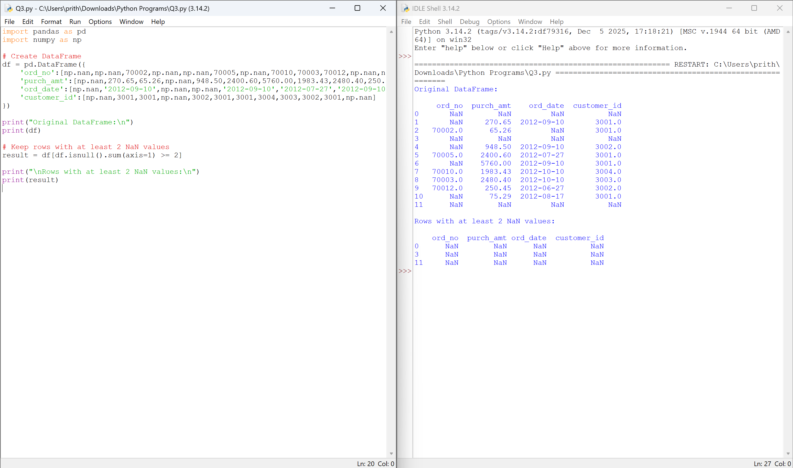

16. Write a Pandas program to split the dataframe into groups based on school code. Also check the type of GroupBy object.
Aim
To write a Pandas program to group the DataFrame based on the school code and display the type of the GroupBy object.
Algorithm
- Import the pandas library.
- Create the DataFrame.
- Group the DataFrame using groupby('school').
- Display the type of the GroupBy object.
- Print each group separately.
Code
import pandas as pd
df = pd.DataFrame({
'school':['s001','s002','s003','s001','s002','s004'],
'class':['V','V','VI','VI','V','VI'],
'name':['Alberto Franco','Gino Mcneill','Ryan Parkes',
'Eesha Hinton','Gino Mcneill','David Parkes'],
'date_Of_Birth':['15/05/2002','17/05/2002','16/02/1999',
'25/09/1998','11/05/2002','15/09/1997'],
'age':[12,12,13,13,14,12],
'height':[173,192,186,167,151,159],
'weight':[35,32,33,30,31,32],
'address':['street1','street2','street3','street1','street2','street4']
})
print("Original DataFrame:\n")
print(df)
grouped = df.groupby('school')
print("\nType of GroupBy Object:")
print(type(grouped))
print("\nGroups:")
for school, group in grouped:
print("\nSchool:", school)
print(group)
Input
The DataFrame containing student details.
Output
Type of GroupBy Object:
<class 'pandas.core.groupby.generic.DataFrameGroupBy'>
School: s001
(Displays students of s001)
School: s002
(Displays students of s002)
School: s003
(Displays students of s003)
School: s004
(Displays students of s004)
Result
Thus, the DataFrame was successfully grouped according to the school code, and the type of the GroupBy object was displayed.
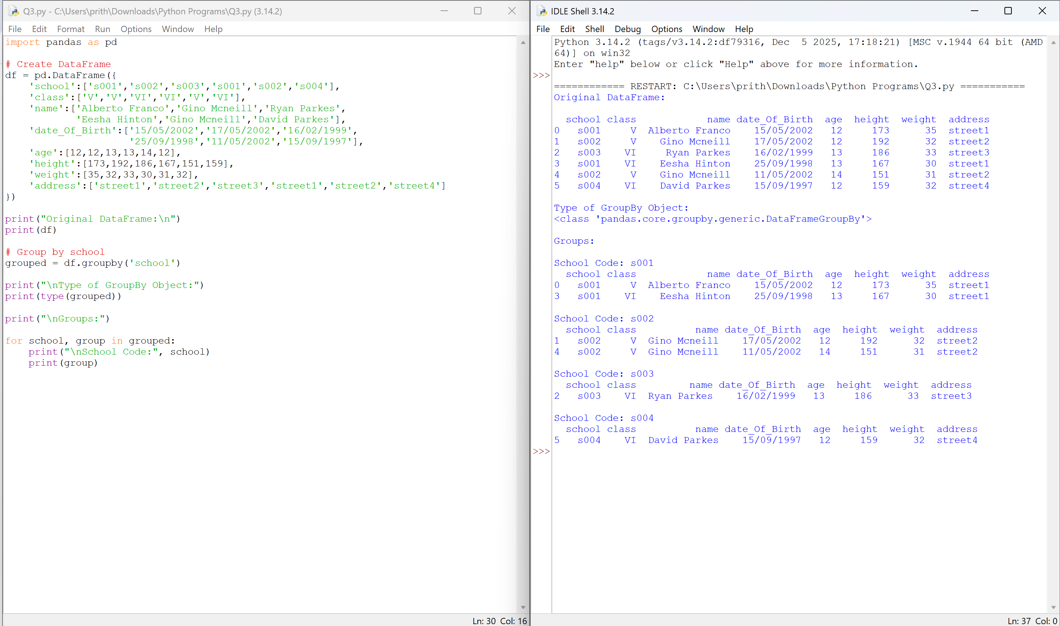

17. Write a Pandas program to split the dataframe by school code and get mean, min, and max value of age for each school.
Aim
To write a Pandas program to calculate the mean, minimum, and maximum age of students for each school.
Algorithm
- Import the pandas library.
- Create the DataFrame.
- Group the DataFrame by the school column.
- Apply the aggregation functions mean(), min(), and max() on the age column.
- Display the result.

Code
import pandas as pd
df = pd.DataFrame({
'school':['s001','s002','s003','s001','s002','s004'],
'class':['V','V','VI','VI','V','VI'],
'name':['Alberto Franco','Gino Mcneill','Ryan Parkes',
'Eesha Hinton','Gino Mcneill','David Parkes'],
'date_Of_Birth':['15/05/2002','17/05/2002','16/02/1999',
'25/09/1998','11/05/2002','15/09/1997'],
'age':[12,12,13,13,14,12],
'height':[173,192,186,167,151,159],
'weight':[35,32,33,30,31,32],
'address':['street1','street2','street3','street1','street2','street4']
})
print("Original DataFrame:\n")
print(df)
result = df.groupby('school')['age'].agg(['mean','min','max'])
print("\nMean, Min and Max Age for each School:\n")
print(result)
Input
The DataFrame containing student details with school codes and ages.
Output
Mean, Min and Max Age for each School
mean min max
school
s001 12.5 12 13
s002 13.0 12 14
s003 13.0 13 13
s004 12.0 12 12
Result
Thus, the Pandas program successfully grouped the data by school code and calculated the mean, minimum, and maximum age for each school.

